KE5Y -

Functionality
This transaction calls up an plan line item report. G/L record type (1 = plan, 3 = plan assessment/distribution in Profit Center Accounting).

Scenario
You want to display all plan line items in version 1 coming from CO-PA plan data transfer to EC-PCA in the whole year 2002.

Requirements
Any document with plan data was posted.

Menu Path | SAP menu → Accounting → Controlling → Profit Center Accounting → Information System → Reports for Profit Center Accounting → Line Item Reports → KE5Y - Profit Center: Plan Line Items
Transaction Code | KE5Y

1. Double Click on KE5Y - Profit Center: Plan Line Items.

Profit Center: Plan Line Items

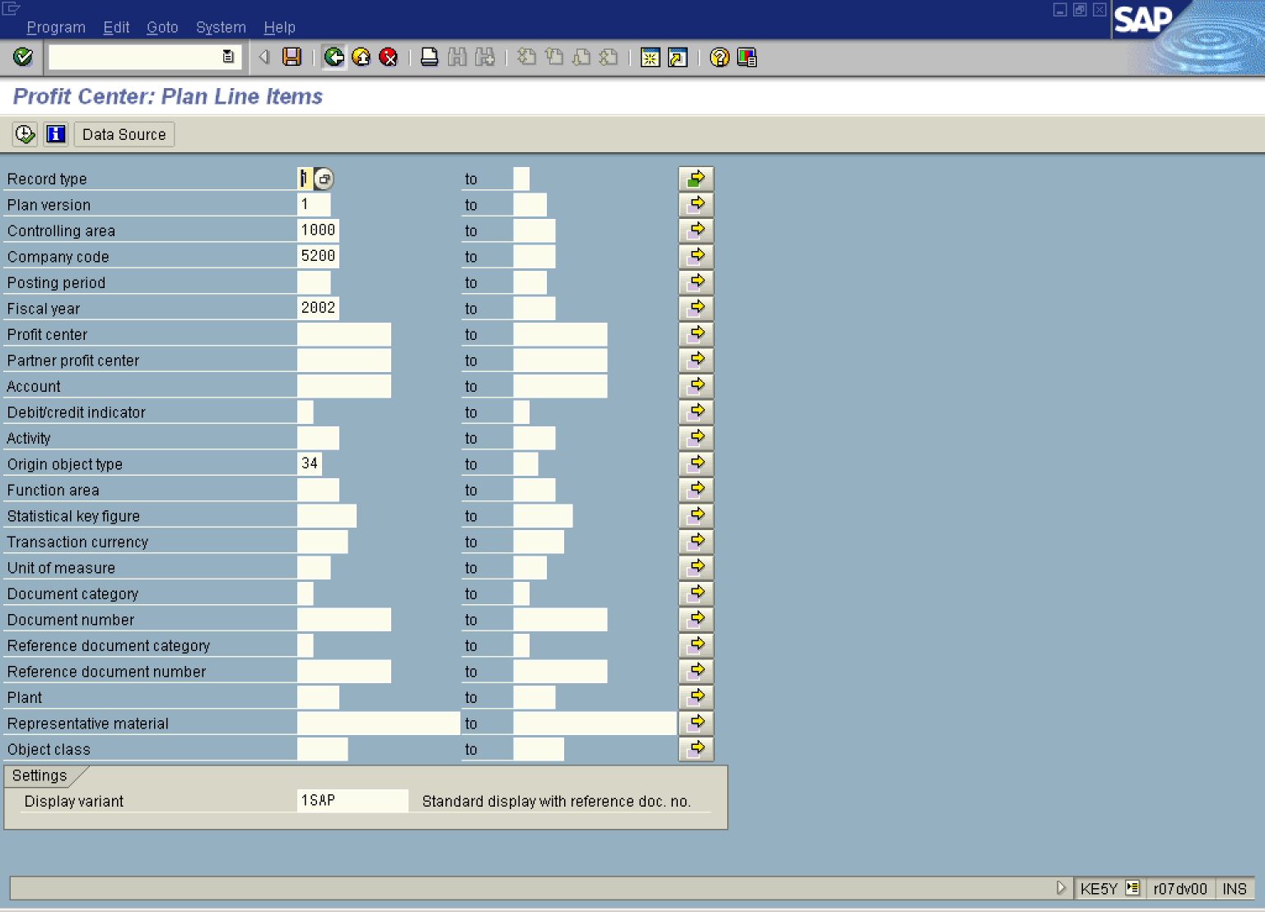

2. Update the following fields:

Field Name | Field Description | Values
Controlling area | Code identifying the highest level of the legal entity for which cost center accounting and profit center accounting can be consolidated | Example: 1000
Company code | Organizational unit within financial accounting. | Example: 5200
Fiscal year | Relevant Fiscal year. | Example: 2002
Origin object type | Origin planning object type, i.e. 34 ‘Profitability segment in costing-based CO-PA’ | Example: 34

3. Click .

Profit Center: Plan Line Items

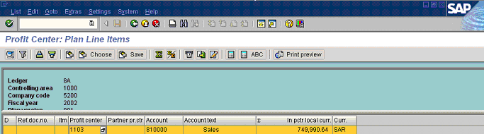

4. Double Click on 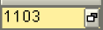.

Document R - 500227 - 001 / Ref.Document - - 000:Period Breakdown

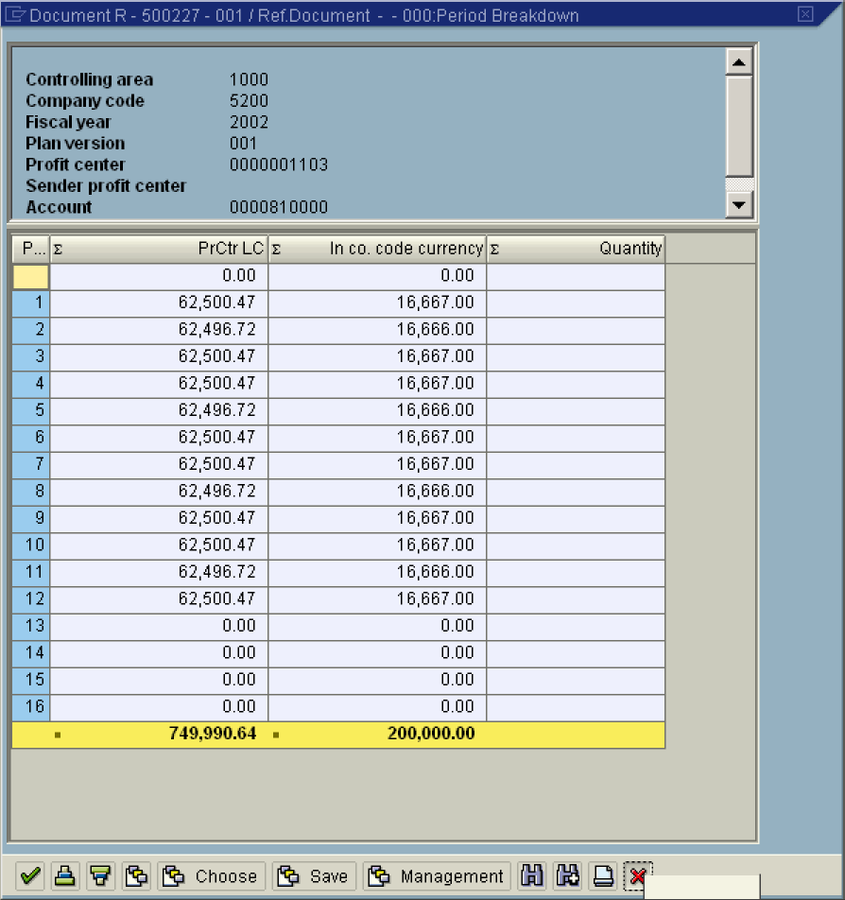

5. Click Cancel button.

Profit Center: Plan Line Items

6. Click Back .

